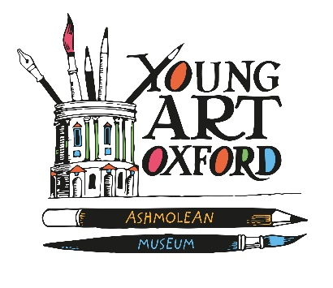
SUMMARY OF ENTRIES FOR 2019

Name of School………………………………………………………………………………………….

Name of Teacher………………………………………………………………………………….

Name of Rep (if different from above)…………………………………………………………

Year Group | No of Entries | Entry fee paid (£2 per entry)
Rec – Year 2

Year 3 – Year 4

Year 5 – Year 6

Year 7 – Year 9

Total

Please make sure that you have enclosed the following with this form:
- The entry fee in the form of cash or a cheque made payable to ‘Young Art Oxford’. Alternatively it is possible to make a bank transfer (LLoyds TSB Bank, Young Art Oxford, Account: 00262815,Sort code: 309635, ref: entry fees + school name)
- Signed consent form from the school
- Typewritten list of the names of all the children entering the competition

